e-Learning Platform

**By :-** **DevDynamos**

**Dated :- 21th September , 2023**

**Mentor :- Mr. Nitin Bhide**

**UI/UX DESIGN:**

**About the Project:**

In this project we will explore how e-Learning Platform Transformed Traditional Education, Offering Dynamic Courses, Personalized Learning Paths, And Seamless Interaction for an Enriched Academic Experience

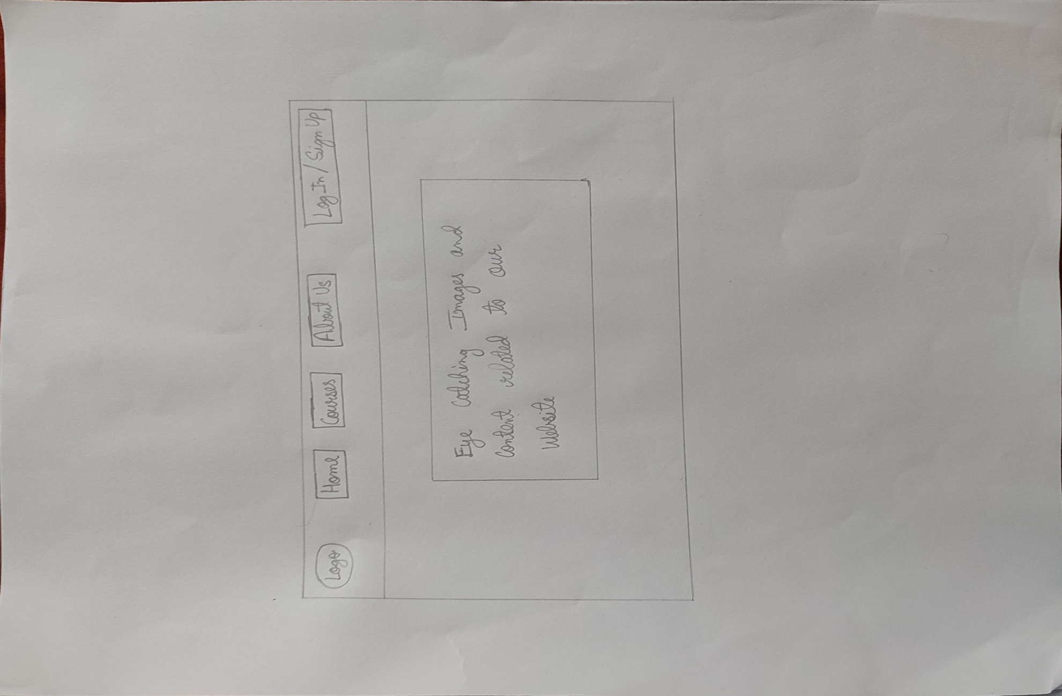

**Home Page**

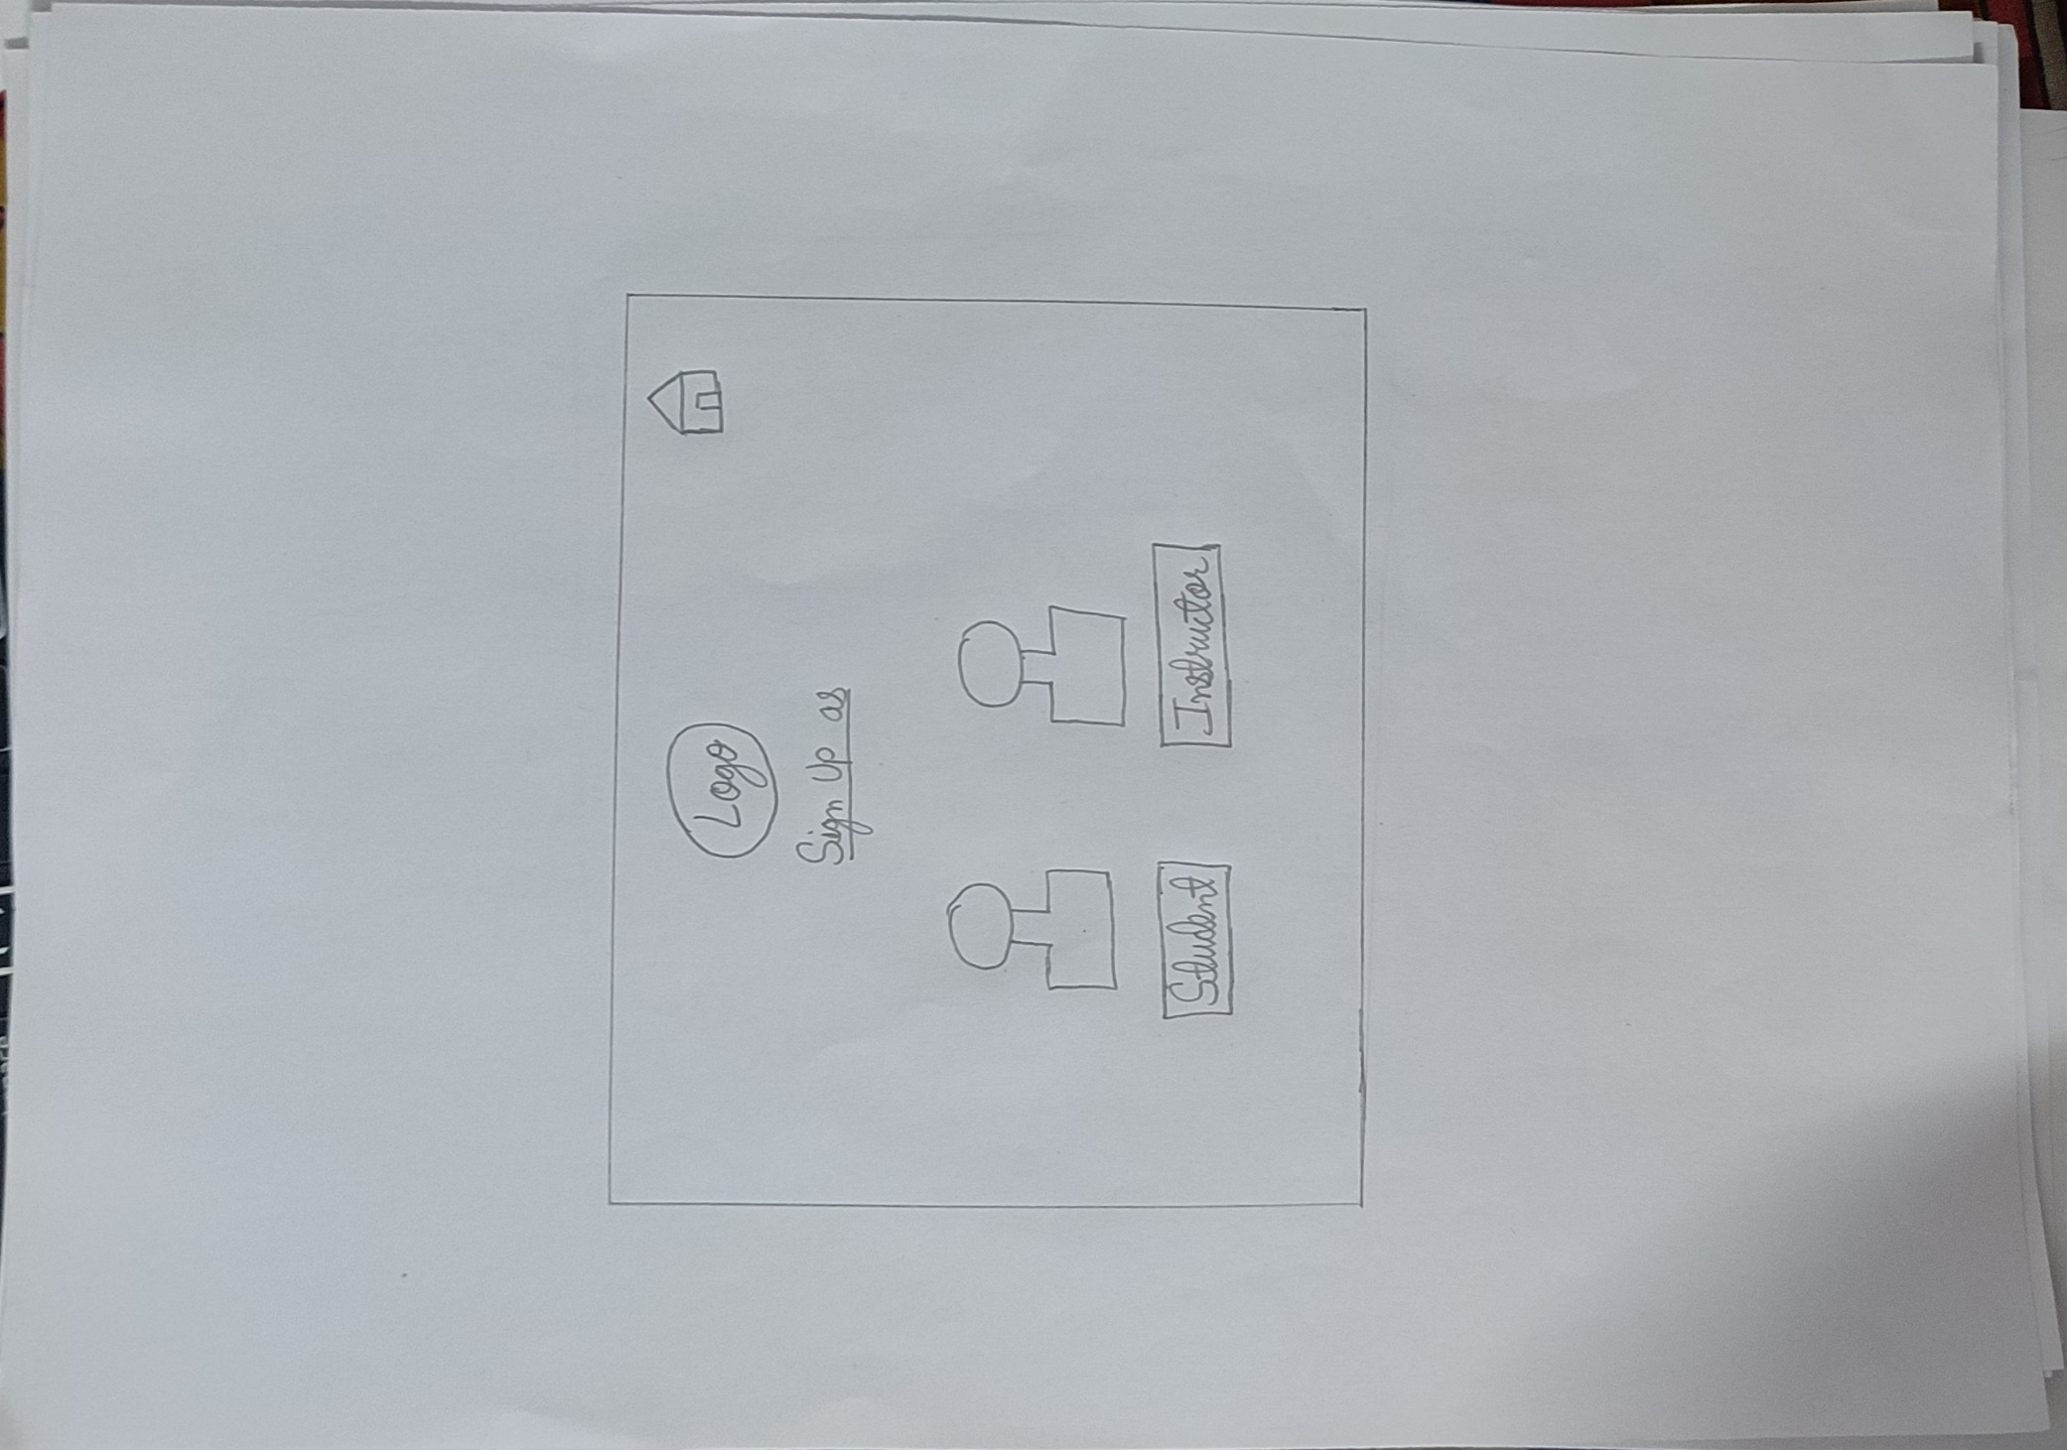**Sign up**

**Sign up as Student**

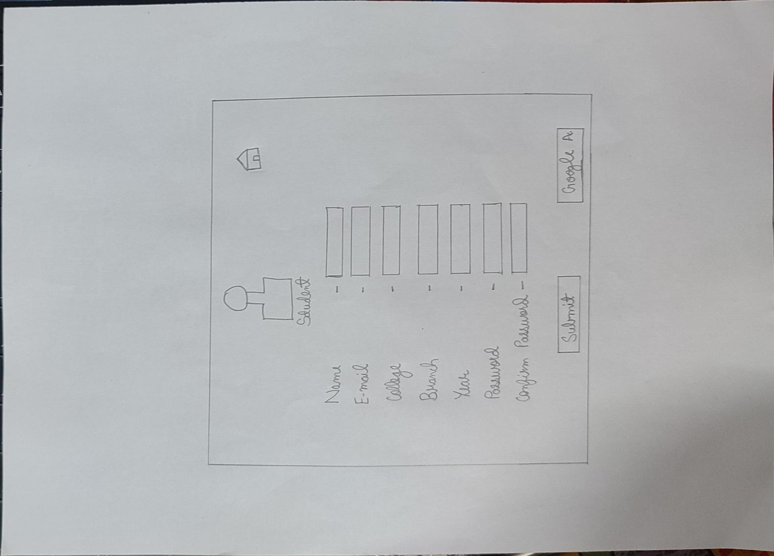

**Sign up as Instructor**

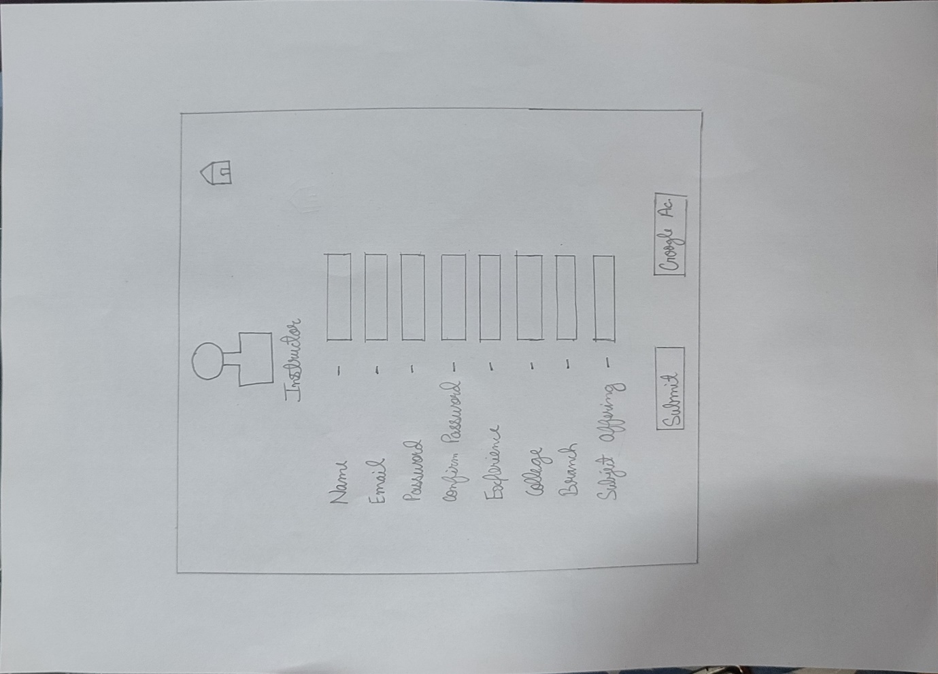

**Log In as Student**

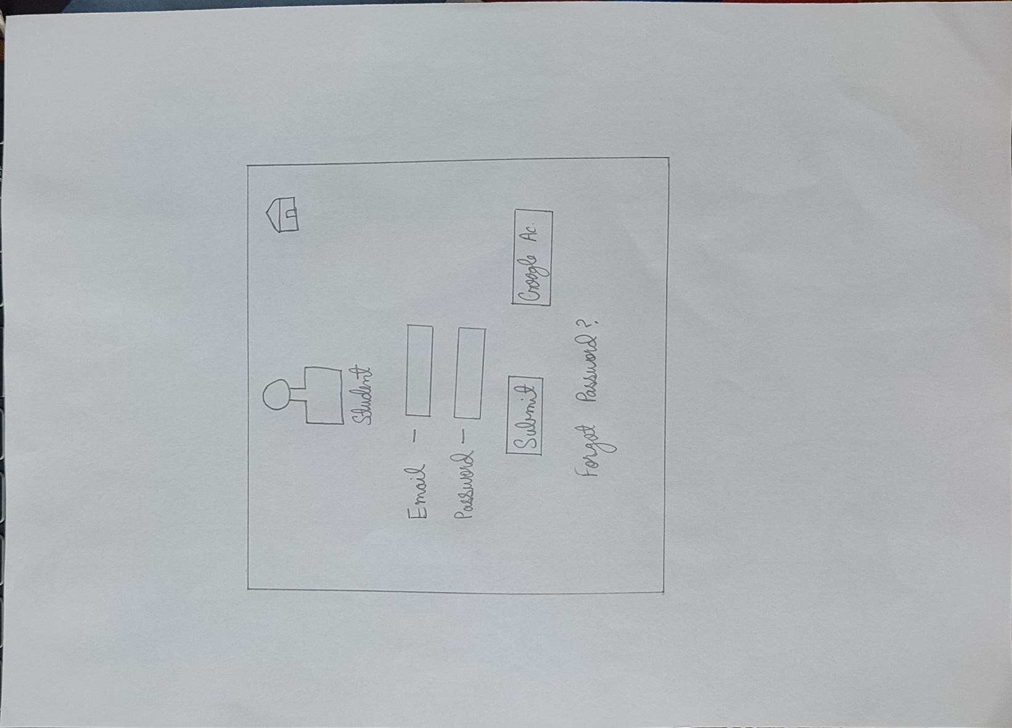

**Log In as Instructor**

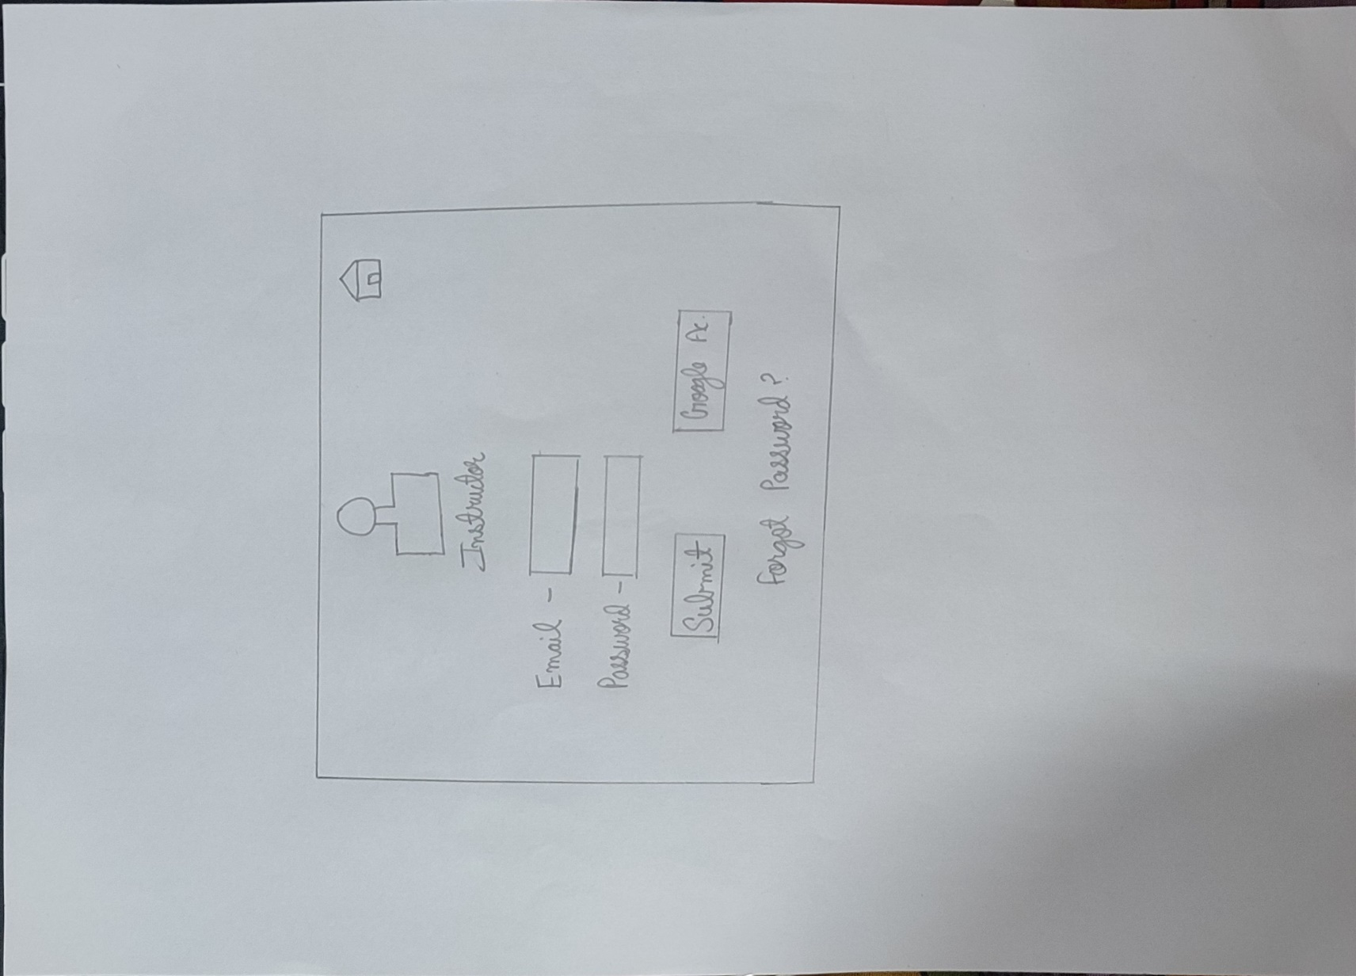

**About us**

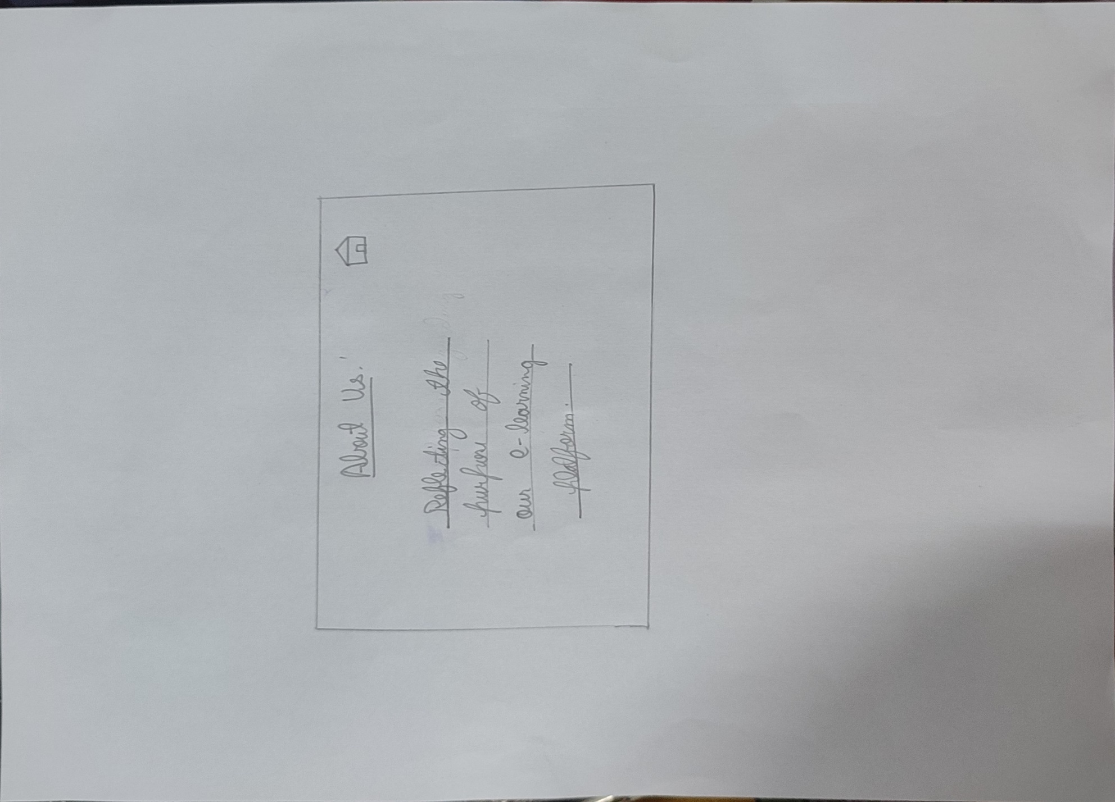

**Courses**

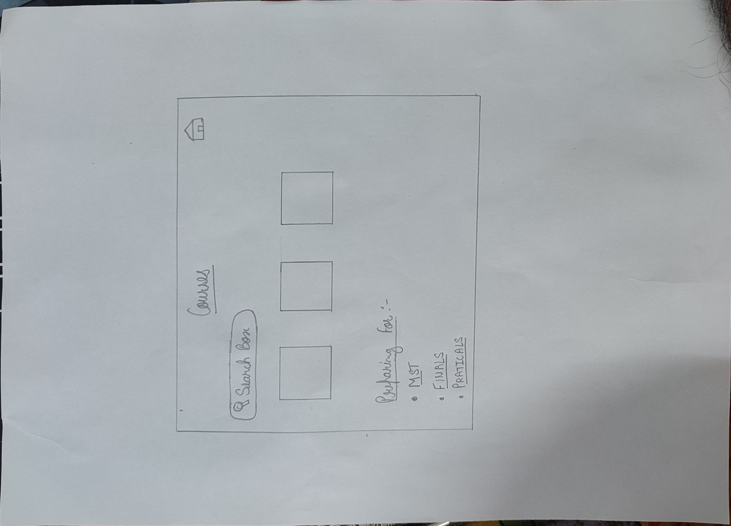

**Dashboard for Student**

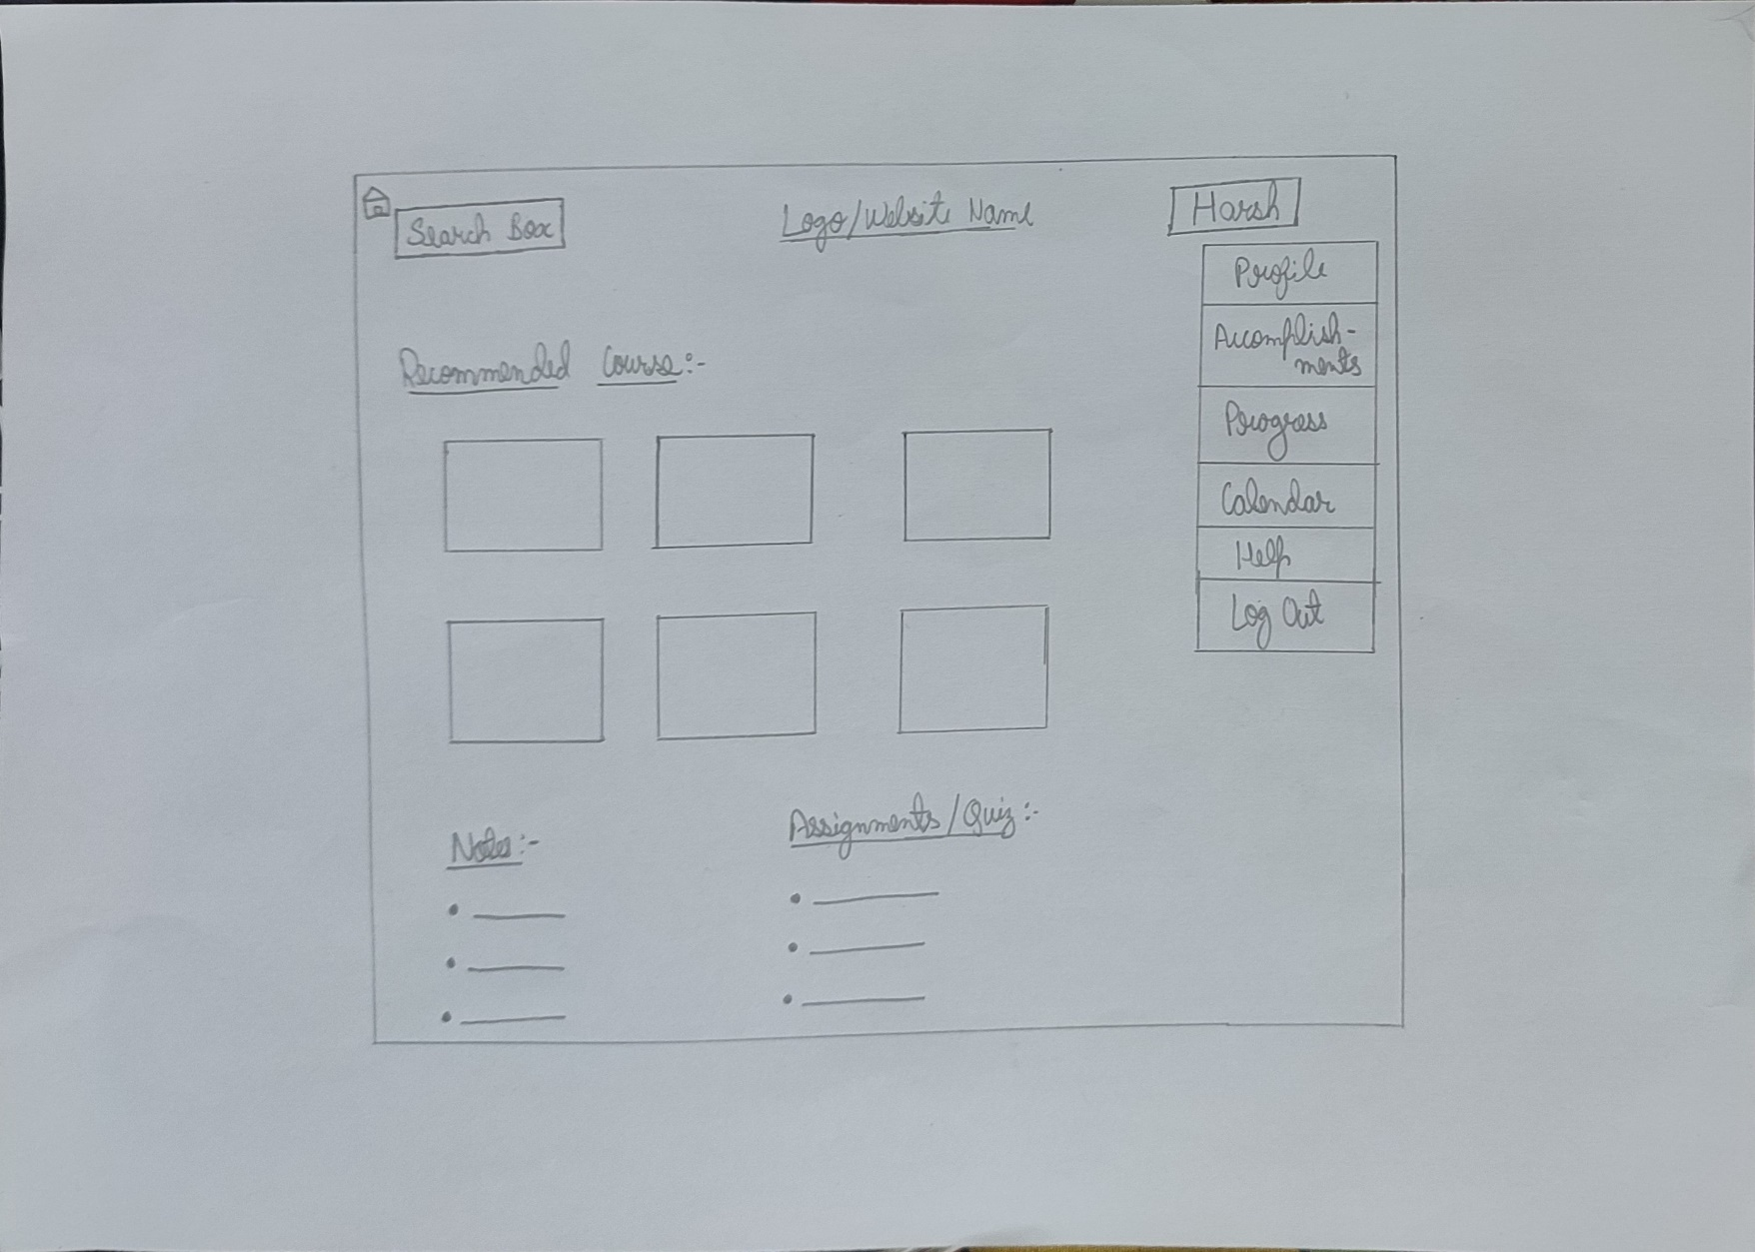

**Dashboard for Instructor**

